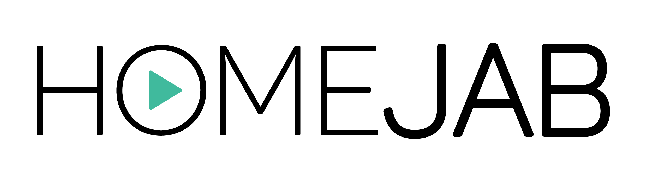
NFT MARKETPLACE by

NFTs: Frequently Asked Questions

1. What is the NFTs Marketplace by HomeJab?

HomeJab, as a leader in on-demand professional real estate photography and video services for real estate pros, is offering the new NTF Marketplace by HomeJab for real estate photos. The NFT Marketplace is where real estate photographers can create and sell their professional photos for consumers to use for digital marketing, collect or trade online.

2. What kind of NFTs does the NFT Marketplace feature?

Each NFT is a unique portrayal of a real-world landmark, landscape, building, home, or other iconic real estate photo created by an artist who is local to their community.

3. How does an NFT benefit the professional real estate photographer?

When an NFT is created by a professional real estate photographer or “artist,” it is traced back to that artist with every transaction in the form of a royalty payment. This ensures that the original artist is always credited and rewarded for their work.

4. Why do this with an NFT?

HomeJab leadership believes creating images as NFTs is the best way to protect the ownership and usage of these images while also protecting the original artist who created them. The NFT Marketplace provides a safe haven for all digital imagery, protecting the creator and the consumer.

Online image theft is rampant, especially in real estate photography. And while using an image without securing proper authorization seems harmless, it’s quite damaging for the artist who creates the image. Unfortunately, photographers today offer their work without protection for very little pay. The NFT Marketplace protects the ownership of an artist's digital portfolio while rewarding professional photographers for their hard work.

5. What are the benefits of using the NFT Marketplace?

When you purchase an NFT through the NFT Marketplace, you own a unique piece of real-world history and support a real-life artist. Most photographers work as independent contractors, with little ability to control or monitor their work after a shoot is complete. Furthermore, once their work is published, possession typically is out of the artist’s control. The NFT Marketplace by HomeJab is the only place, real or digital, that secures their efforts and delivers the potential to receive continuing compensation from their work.

6. How does the NFT Marketplace work?

Creating an NFT via the NFT Marketplace has been designed to be quick and easy. It includes these simple four steps:

- Set up your crypto wallet with MetaMask: Once you’ve set up your MetaMask wallet, connect it to the NFT Marketplace online, clicking on the green “Connect Wallet” button on the top right corner of this page.
- Create your NFTs: The marketplace allows you to click to create your NFTs by uploading your work, adding a title and description, and customizing your NFTs with properties, stats, and unlockable content.
- List them for sale: You choose the listing prices you want to set for each NFT. Then, you pick the price, and the NFT Marketplace helps you sell them!
- Receive royalties: You receive 96% of the sale price with every initial sale. In addition, with every resale, you can receive up to 10% of the resale price, based on the royalty amount you set.

If there are any issues, the NFT Marketplace by HomeJab offers free customer support at HomeJab.com.

7. Who can use the NFT Marketplace?

Professional photographers: All the artists ‘minting’ NFTs on the NFT Marketplace are professional real estate photographers. It is the only marketplace for photographers created by photographers. Thus, this new marketplace helps photographers worldwide get appropriately rewarded for their hard work.

Real estate agents: The main buyers using the marketplace are real agents. Real estate agents are the number one consumers of real estate photography. There are an estimated 2 million licensed real estate agents in the U.S. Real estate images are an essential element of every agent’s marketing campaign for each property they sell.

Business owners: This marketplace also has broader use. Any business owner can take advantage of the digital ownership they receive with NFTs. These images can be used for company websites, marketing material for hospitality groups, and advertising campaigns for large-scale projects – just like images purchased through stock image firms. NFTs have a huge advantage over stock photos: NFTs are entirely unique. While your competitors may buy and use the same stock photos you licensed, with an NFT, you own and control all rights to that unique image.

Journalists and Bloggers: The greatest volume of online content comes from journalists and bloggers. Real estate is one of the most popular types of online content, and this content needs supporting images. Media can purchase NFTs for their exclusive use.

Digital Art Collectors: In addition to providing NFTs for business and residential needs, the NFT Marketplace also houses many national landmarks and iconic real estate images – all one-of-a-kind, single edition. Digital art collectors can uniquely own Times Square, the Hollywood Sign, or any classic landmark with single-issued digital artwork.

8. How much does it cost to use the NFT Marketplace?

There is no cost to join the marketplace or create an NFT other than the individual costs to set up a crypto wallet with digital currency and pay a small (typically under $2) gas fee to post an NFT for sale. Please note that HomeJab does not get compensated until the NFT sells, and takes a small commission (4%): 96% of the purchase funds goes directly to the photographer who created the NFT.

You can learn more at nft.homejab.com.

# # #
Media contact:

Kevin Hawkins (206) 866-1220
kevin@wavgroup.com

